**

**Mathematics Methods Unit 3**

# Test 3 – Integration and Discrete Random Variables

|  |
| --- |
| **Name: ______________________ Total Marks:__________** |
|  |
|  |

**Task type: Response**

**Time allowed for this task:**  60 minutes, in-class, under test conditions

Calculator Free – 35 minutes

Calculator-assumed - 25 minutes

**Materials required:** Calculator with CAS capability (to be provided by the student)

**Standard items:** Pens (blue/black preferred) , pencils (including coloured), sharpener, correction fluid/tape, eraser, ruler, highlighters

**Special items:**  Drawing instruments, templates, notes on one unfolded sheets of   
A4 paper, and up to three calculators approved for use in the WACE examinations

**Marks available: 58 marks**

**Task weighting: 7%**

**Section One - Calculator Free Total: 34 marks**

**Question 1** **[7 marks]**

Determine the value of

(a) $\int_{1}^{2}{\underset{ }{\overset{ }{3x^{4}}}}dx$. (3 mark)

(b) (4 marks)

$$\int_{1}^{4}{ ( \frac{2}{x^{3}} - \frac{1}{2\sqrt{x}} ) dx}$$

**Question 2** **[2 marks]**

Find $\frac{dy}{dx}$ given:

$$y= \int_{1}^{x}{\sqrt{1+ t^{3} } dt}$$

**Question 3** **[7 marks]**

The graph of $y=f(x)$ is shown below for $-4≤x≤5$.

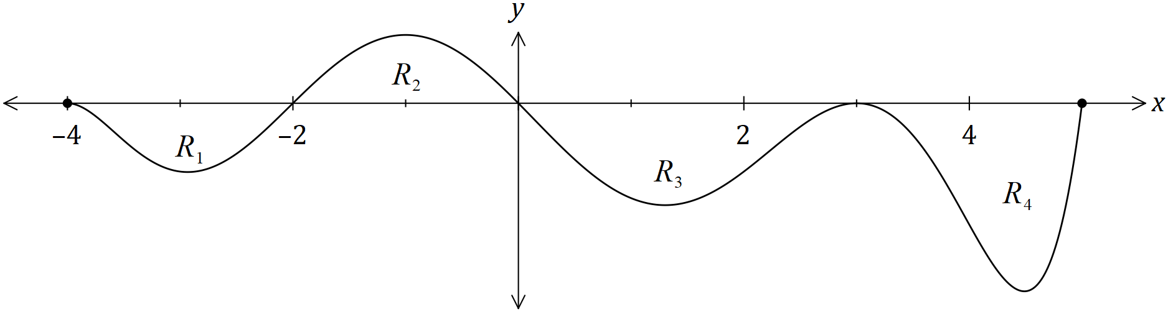

The area trapped between the $x$-axis and the curve for regions $R_{1}, R_{2}, R_{3}$ and $R_{4}$ are $21, 25, 43$ and $32$ square units respectively.

(a) Determine the value of

(i) $\int_{3}^{5}{\underset{ }{\overset{ }{f(x)}}}dx$. (1 mark)

(ii) $\int_{-4}^{3}{\underset{ }{\overset{ }{f(x)}}}dx$. (2 marks)

(iii) $\int_{-4}^{0}{\underset{ }{\overset{ }{\left(f(x)-5\right)}}}dx$. (2 marks)

(iv) $\int_{-2}^{3}{\underset{ }{\overset{ }{f(x)}}}dx+\int_{3}^{5}{\underset{ }{\overset{ }{f'(x)}}}dx$. (2 marks)

**Question 4 (5 marks)**

The random variable $X$ has a the probability distribution shown in the table.

|  |  |  |  |  |  |
| --- | --- | --- | --- | --- | --- |
| $$x$$ | 0 | 1 | 2 | 3 | 4 |
| $$P(X=x)$$ | 0.1 | 0.5 | $$k$$ | 0.2 | 0.05 |

1. i) Find the value of $k$ (1 mark)

ii) Find the expected value of $X$ (1 mark)

iii) $E(5X-3)$ (1 mark)

1. Given that the $Var(X)$ = 1.3. Find
   1. $Var(5X-3)$ (1 mark)
   2. $Var(2-3X)$ (1 mark)

**Question 5 (6 marks)**

A calculator will generate a single random integer n, where $1≤n≤5.$ The program is run once, and the random variable $X$ is the number of even numbers obtained.

1. Explain why $X$ is a Bernoulli random variable. (1 mark)
2. Determine $P(X=1).$ (1 mark)
3. Determine the mean and standard deviation of $X$. (2 marks)

The random variable Y is the number even numbers obtained in three runs of the program.

1. Determine $P(Y≤2)$

(2 marks)

Question 6 (7 marks)

A vehicle travelling in a straight line has a velocity of ms-1 as it leaves point $P$. The acceleration of the vehicle is given by ms-2, where is the time in seconds since the vehicle left $P$.

(a) Determine the velocity of the vehicle when $t=3$. (3 marks)

(b) Determine how far from $P$ the vehicle first comes to rest for $t>0$. (4 marks)

**Section Two – Resources Allowed Name:__________________________**

**Total: 24 marks**

Question 7 (6 marks)

The diagram below shows two estimates of the area enclosed by , the x axis and the y axis. The diagram on the left shows an overestimate of the area. The diagram on the right shows an underestimate of the enclosed area

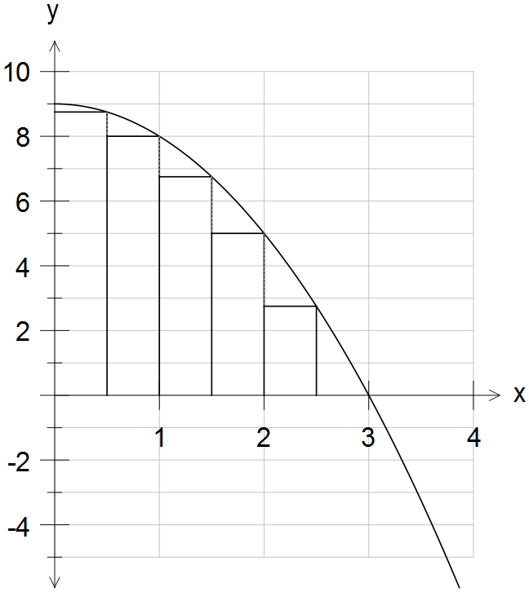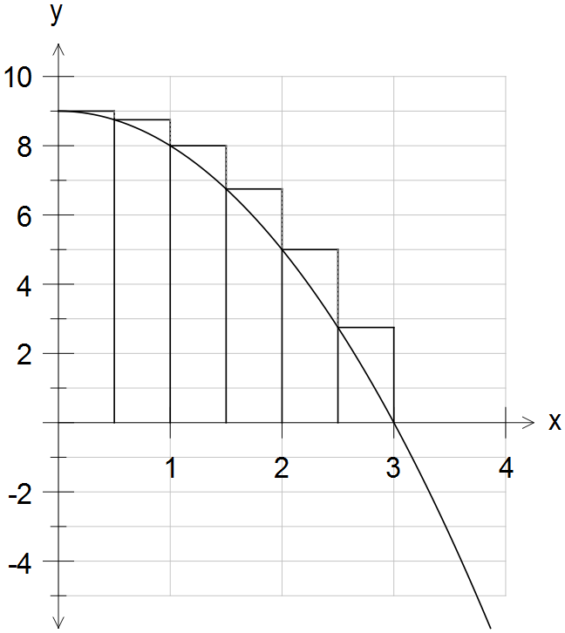

a) The overestimate area is 20.125 square units. (2 mark)

Calculate the underestimate of the enclosed area.

b) Use the under and overestimate to estimate an approximate area under the curve.

(1 mark)

c) Calculate the difference between this estimate and the actual area trapped between the curve and the x-axis.

(3 marks)

Question 8 (4 marks)

X is a uniform discrete random variable where x=2,3,5,7,11

1. Determine
   1. P(X $>6)$ (1 mark)
   2. $P\left(X<3 | X≤7\right)$ (1 mark)
2. Calculate the exact value of
3. E(X). (1 mark)
4. Var(X). (1 mark)

Question 9 (3 marks)

The curves 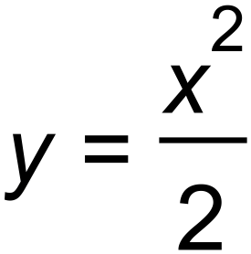 and 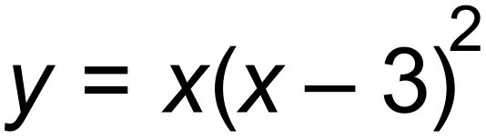 are graphed below. Write an integral expression that when evaluated gives the area trapped between the two curves. Use an efficient method to evaluate the expression correct to 2 decimal places.

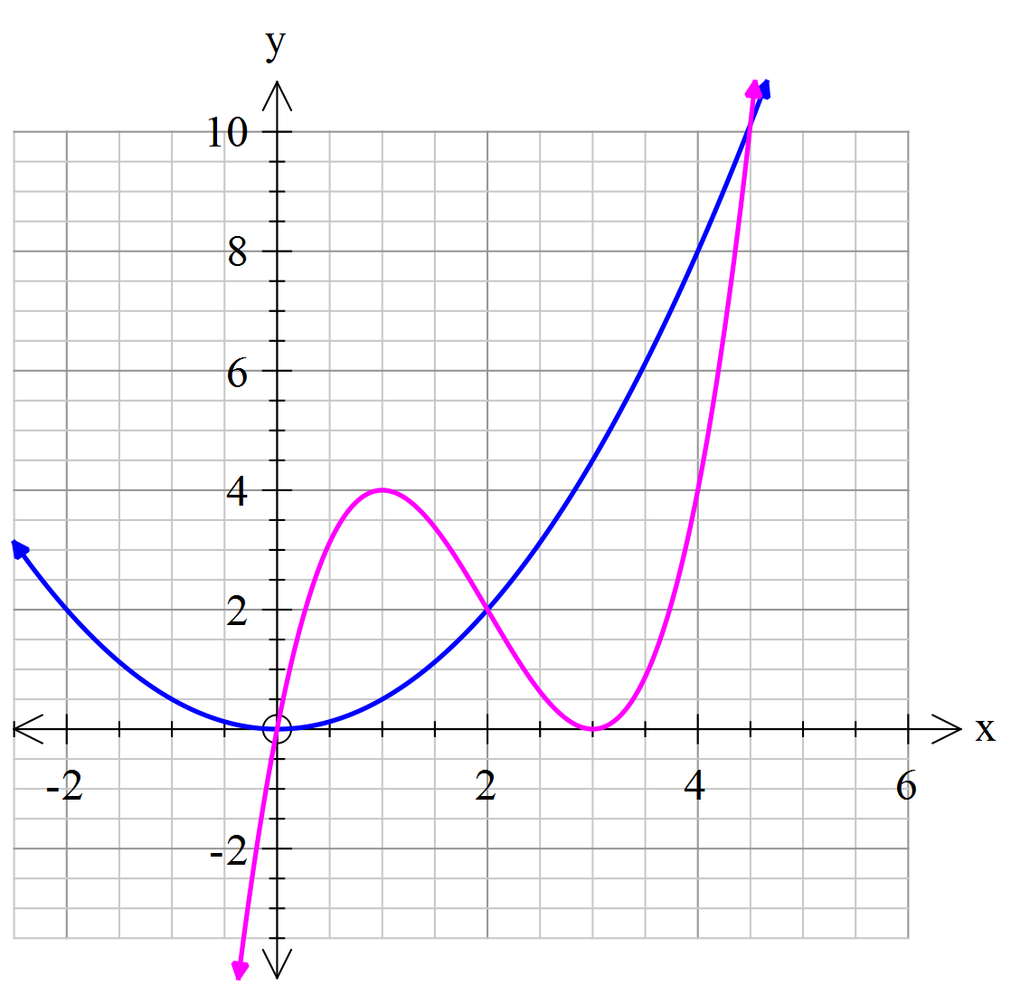

Question 10 (6 marks)

Studies in Britain have recorded that 1 in 100 eight year-old children need at least one tooth removed caused by sugary drinks and severe tooth decay.

A typical primary school class of 24 eight year-olds are investigated for the need to remove at least one tooth.

Determine the probability of:

1. 2 students needing at least one tooth removed. (2 marks)
2. No students requiring the removal of any teeth. (1 mark)
3. At least one student requiring the removal of at least one tooth. (1 mark)
4. Less than 4 students requiring the removal of at least one tooth given that at least one student required tooth removal. (2 marks)

**Question 11 (5 marks)**

A train stops at a certain train station 12 times a day and is late 25% of the time.

Calculate, correct to 3 decimal places,

(a) the probability that the train will be late 3 times, on any particular day. (2 marks)

(b) the probability that the train is late 4 times for at least 2 out of the next 8 days. (3 marks)